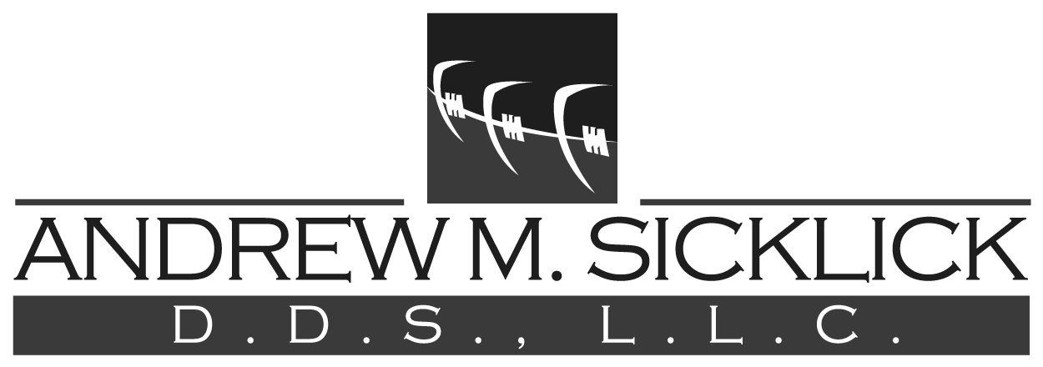
Practice Limited to Orthodontics
123 Grove Ave. – Suite 107
Cedarhurst, NY 11516
(516) 569-5559
bracesdoc@optonline.net

Appointment Cancellation Policy

We will make every effort to remind patients by telephone prior to their appointment, but please do not depend on this courtesy. We have found that with the recent popular use of voice mail, some of our patients are not receiving our reminder calls due to the lack of space available in these mailboxes. If you use voice mail, we kindly ask that you return our call to confirm that you received our message. If we are unable to contact you directly, your appointment card or appointment phone call will serve as confirmation of your appointment, and it implies your obligation to be present. Your appointment time has been reserved especially for you, and we strongly encourage all patients to keep their appointments and to be on time. If you must change your appointment, we require at least 24 hours notice to avoid a minimum $50 cancellation fee.

Signature_________________________________ Date_____________________

