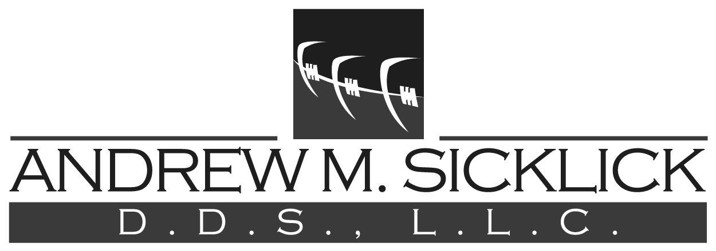
Practice Limited to Orthodontics
123 Grove Ave. – Suite 107
Cedarhurst, NY 11516
(516) 569-5559
bracesdoc@optonline.net

To our patients and parents:

Over the past several years, our office has observed a significant increase in the use and administration of growth hormone for our children. We are confident that all families that have chosen to provide their growing children with any hormone therapy are under the care of an endocrinologist. The endocrinologist is responsible for all decisions regarding this treatment.

Hormone treatment alters the rate and amount of bone growth throughout the body, including the head and face. Orthodontists are often needed as part of growth hormone treatment because of the possible change in the patient’s skeletal pattern, specifically a significant change in the growth of the mandible (lower jaw). It is common and expected for growth hormone to adversely affect orthodontic treatment, both during active treatment and after its completion, in the active and inactive retention phases. Orthodontic treatment may be needed following growth hormone therapy, whether or not one had previously received orthodontic treatment.

Therefore, it is absolutely imperative for us to know if a patient is receiving hormone treatment and who is the responsible endocrinologist.

Again, this information is required for us to be successful in working with you to achieve the best orthodontic outcome.

________________________ __________ ____________________________
Patient Date Endocrinologist

Check here if patient is NOT taking receiving growth hormone:

_________________________________ _______________________________
Signature of responsible party Relationship of responsible party

